NAPPC Roadside Managers Award

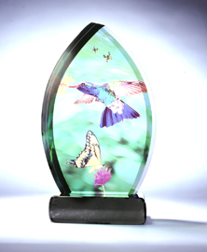
Pollinator Roadways is a new initiative of the North American Pollinator Protection Campaign (NAPPC) to recognize transportation agencies who are leading the field in pollinator-friendly roadside practices. In 2018 NAPPC will be awarding its 3rd annual Pollinator Roadside Management Award.

The Awards
There will be an award for state projects and another for county/local/regional projects.

Award Criteria – Government Transportation Agency
- Demonstrates an exemplary long-term commitment to provide pollinator habitat along roadsides.
- Plants or seeds pollinator supporting vegetation.
- Promotes vegetation management practices (mowing, pesticide use, etc.) within the agency that incorporate the needs of pollinators.
- Can describe the positive impacts of the agency’s pollinator initiative for animals and people.
- Engages the public through education and outreach as well as signage.
- Documented roadside miles impacted by the agency’s pollinator initiative, and plans for the future.

Key Dates
- Nomination Period: September 18, 2017 – June 1, 2018
- Deadline for Applications: June 1, 2018
- Award Announced: Summer/Fall 2018

Nominations
To nominate a transportation agency please complete an online application at www.pollinator.org/roadsides#roadsides-manager-award or email the completed form below to info@pollinator.org by June 1, 2018.

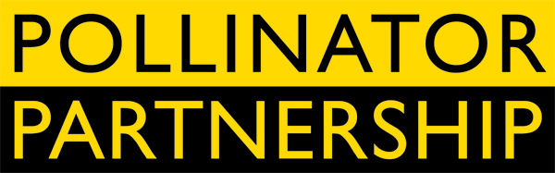

Pollinator Partnership (P2)
Established in 1997, the Pollinator Partnership is the largest 501(c) 3 non-profit organization dedicated exclusively to the health, protection, and conservation of all pollinating animals. All P2 projects are science-based and collaborative and support conservation, education, research, policy and monitoring. Further information is at www.pollinator.org.

2018 NAPPC Pollinator Roadside Management Award
(Use as much space as needed to completely answer each question)

Contact Information (Nomination submitter)
Name: ______________________________________ Organization: ________________________________________
Email: _____________________________________Phone:________________________________________________
Government Agency Information (Nominee)
Agency Name (Note if State or County/Local/Regional):____________________________________________________
Employee Contact Name: __________________________ Title: ________________________________________
Email: __________________________________________ Phone: _______________________________________
Please address each of the questions below in as much detail as possible.
- How has the agency demonstrated an exemplary long-term commitment to provide pollinator habitat along roadsides?

- How has pollinator supporting vegetation been incorporated into the agency’s activities. What species are being used?

- How is the agency promoting vegetation management practices (mowing, pesticide use, etc.) that incorporate the needs of pollinators?

- Explain the measured positive impacts of the agency’s pollinator initiative for animals and people.

- Describe how the agency engages the public through education and outreach as well as signage.

- Provide the amount of documented roadside miles impacted by the agency’s pollinator initiative.

Provide three specific examples of how the agency has managed roadsides for pollinators.

How has the nominated agency demonstrated a commitment to pollinators in the future?

Insert a labeled picture(s) of the section(s) of roadside the agency has managed for pollinators at the end of this form.

