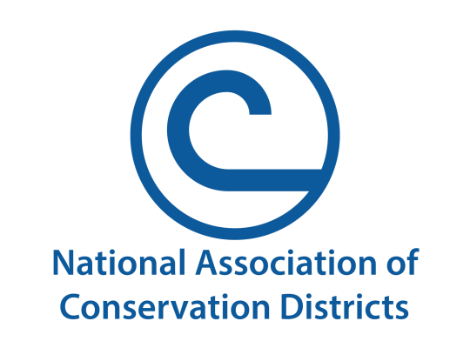
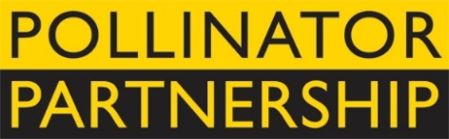
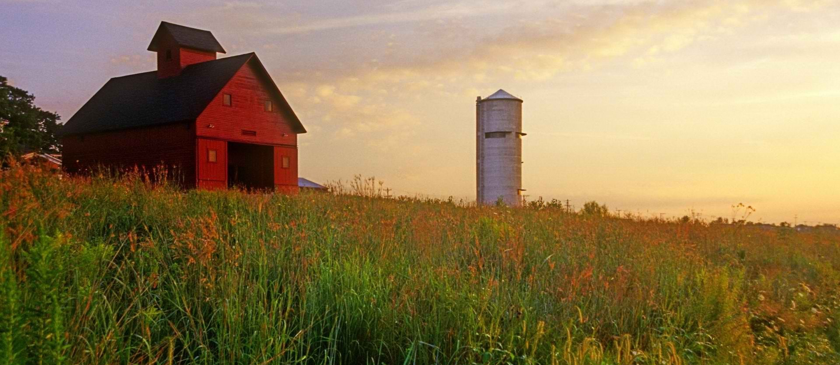
NAPPC Farmer-Rancher
Pollinator Conservation Award

The National Association of Conservation Districts (NACD) and Pollinator Partnership (P2) are pleased to solicit nominees for the 2019 Farmer-Rancher Pollinator Conservation Award, recognizing an individual or family in the farm and ranch community who has contributed significantly to pollinator species protection and conservation.
With pollinators providing one of three bites of food that we eat and nearly $16B to the US agricultural economy, care and concern for their survival is essential to our own survival. Pollinator Conservation Award winners support pollinators on their lands, engage in research and experimentation to increase our understanding of pollinator management techniques, work with community and government groups, and serve as advocates for these little, but hard-working, species that maintain our agricultural and natural landscapes.
The recipients of the 2019 award will be recognized during an evening reception that opens the 19th Annual North American Pollinator Protection Campaign Conference on Tuesday, October 22, 2019 from 6:00 pm to 8:00 pm in Washington, DC, or in their hometown if they are unable to attend.
Previous award winners include John and Nancy Hayden from The Farm Between, Brendon Rockey of Rockey Farms, Lakhy Sran of Sran Family Orchards in California, and Heikes Family Farm from Vermillion, SD. Through recognition and appreciation of these individuals and organization, we hope to encourage their conservation stewardship and catalyze future actions on behalf of pollinators. Visit http://www.pollinator.org/awards.htm to learn more.
To complete your nomination, please return the attached form to Kelly Rourke at the Pollinator Partnership by deadline of Wednesday, July 31, 2019.
Forms can be sent as an e-mail attachment to kr@pollinator.org (please put “Farmer-Rancher Pollinator Conservation Award” as the subject line) or mailed to 475 Sansome St., 17th Floor, San Francisco, CA 94111.

Farmer-Rancher Pollinator Conservation Award Nomination Form
Please return the attached form to Kelly Rourke at the Pollinator Partnership by Wednesday, July 31, 2019. Forms can be sent as an e-mail attachment to kr@pollinator.org (please put “Farmer-Rancher Pollinator Conservation Award” as the subject line) or mailed to 475 Sansome St., 17th Floor, San Francisco, CA 94111.
Supporter’s Information:
Name:
Organization, if applicable:
E-mail: Phone:

I wish to nominate the following individual or family in the farm and ranch community for the Farmer-Rancher Pollinator Conservation Award:
Nominee’s Name:
Farm/Ranch:
E-mail: Phone:

Nomination Narrative (Please provide a narrative or recommendation letter that speaks to the three points listed below. You may use this word document or attach separate sheets. Please keep submission at a maximum of 4 pages, not including images or representative materials):

1. Briefly describe nominees and their farm or ranch operation (location, size, crop, community).

2. Describe the contributions of the individual or family farmer/rancher to pollinator protection and conservation on working and wild lands, including but not limited to “on-the-ground” pollinator conservation, best management practices, landscape management techniques, etc.

3. Describe the contribution of individual or family farmer/rancher to the development of conservation partnerships, research partnership, demonstration projects that promote pollinator awareness and conservation, community and social/political actions that promote and protect pollinators, etc.

