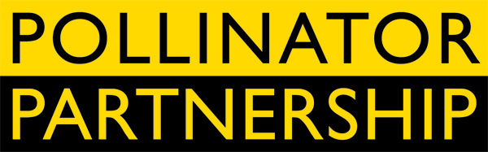

**June 17, 2014**

**For Immediate Release**

Tom Van Arsdall [TVA@pollinator.org](mailto:TVA@pollinator.org) 703.509.4746

Laurie Davies Adams [LDA@pollinator.org](mailto:LDA@pollinator.org) 415.362.1137

**Pollinator Week 2014 Mobilizes America for Pollinators**

The **Pollinator Partnership (P2)** announced today that its signature initiative, **Pollinator Week,** has reached significant new milestones in 2014. Established in 2007, Pollinator Week has grown exponentially in scope each year with this year June 16-22 being designated by **U.S. Secretary of Agriculture Tom Vilsack** and **44 governors** as a week to celebrate and protect the nation’s pollinating animals (acomplete list of State proclamations and events is available at <http://pollinator.org/npw_events.htm>). Pollinators, like bees, butterflies, birds and other animals, bring us one in every three bites of food, protect our environment. They form the underpinnings of a healthy and sustainable future. From the Louisville Middle School on Main Street, Louisville, CO to the Bee Palooza at Michigan State University; from the Unitarian Universalist Church of Asheville, NC to the 3rd-5th graders at the Citizen Science Nature Camp in Houston, TX – Americans have made pollinator health an issue that they are doing something about!

Joining and supporting this effort are some of the largest businesses and most powerful voices in the country. This year has marked a strong surge in interest in the health of America’s pollinators including **First Lady Michelle Obama’s** first-ever White House pollinator garden. Pollinator Week marks a new dawn of wise land management across the country and new initiatives launched during Pollinator Week 2014 will multiply the efforts to support pollinators. The following items are just a start:

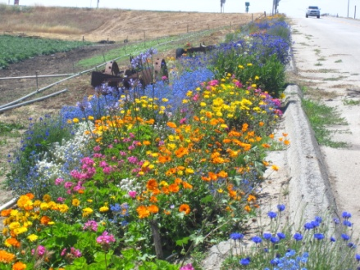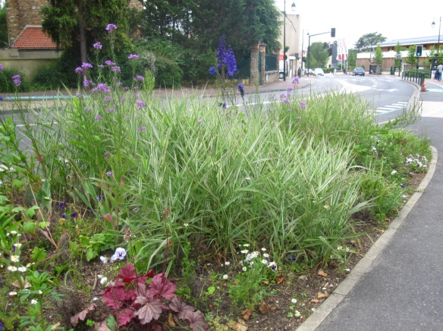The **Highways BEE Act** has been introduced in the Congress by the joint leadership of **Rep. Alcee Hastings (D-FL) and Rep. Jeff Denham (R-CA), co-chairs of the Congressional Pollinator Protection Caucus (CP2C).** Over 200 national, regional, and local organizations and 2,000 American scientists and individuals from all walks of life across the nation have already signed a petition in support. This pollinator action-opportunity continues for all interested organizations, businesses and individuals at <http://www.pollinator.org/BEEAct.htm>.

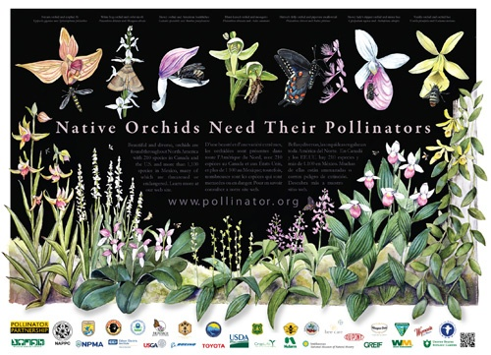

Pollinator Week showcases the brand new pollinator poster of the North American Pollinator Protection Campaign (NAPPC), *Native Orchids Need Their Pollinators.* This 2014 poster marks the debuts of pollinator artist Emily Underwood, a scientific illustrator living and working in central California. The poster is available at [www.pollinator.org](http://www.pollinator.org) where a new web feature illuminates the intricate interactions between wild orchids and their pollinators, including video footage of orchid pollination.

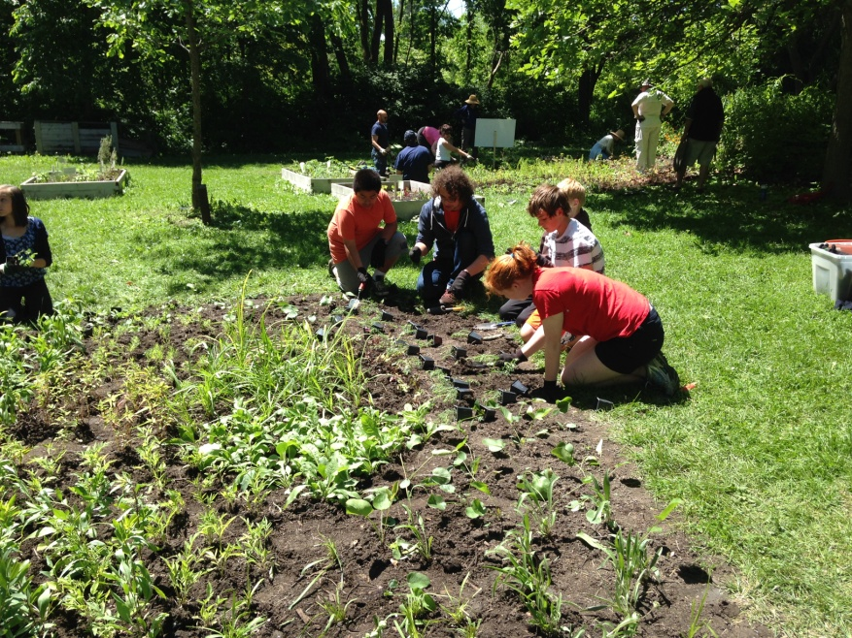To kick off Pollinator Week,the **Pollinator Partnership** teamed with **Walgreens, Burt’s Bees, and the Evanston Ecology Center** to plant a pollinator garden with volunteers from local schools and gardening groups. The garden, located at the Evanston, Illinois Ecology Center, will be a learning resource for people and a much-needed habitat for local and migratory pollinating species. The nearly quarter acre site will be completed with a second planting later in the summer. The garden has been built with funding from the sales of Burt’s Bees lip balm purchased at the new LEED-certified Walgreens in Evanston which opened in the fall of 2013. For information contact [Mark@pollinator.org](mailto:Mark@pollinator.org).

Efforts during Pollinator Week, and indeed year-round, are working to reverse and prevent pollinator declines caused by loss of habitat, disease, pesticides, parasites and other interconnected assaults on pollinator populations. Laurie Davies Adams, Executive Director of P2 said, “It’s appropriate to see the highest levels of government as well as the grassroots individuals and communities taking action for pollinators. We applaud everyone participating in Pollinator Week 2014. It’s a great starting point for actions, large and small, that support the future of our pollinators, our food supply, and our environment.”

###

**ABOUT THE POLLINATOR PARTNERSHIP (P2)**

Established in 1997, the Pollinator Partnership is the largest 501(c) 3 non-profit organization dedicated exclusively to the health, protection, and conservation of all pollinating animals. Pollinator Partnership’s actions for pollinators include education, conservation, restoration, policy, and research. P2’s financial support comes through grants, gifts, memberships and donations from any interested party. P2’s policies are science-based, set by its board of directors, and never influenced by any donor. To make a donation or for information on events during Pollinator Week, visit [www.pollinator.org](http://www.pollinator.org).