

**June 18, 2014**

**For Immediate Release**

Tom Van Arsdall [TVA@pollinator.org](mailto:TVA@pollinator.org) 703.509.4746

Laurie Davies Adams [LDA@pollinator.org](mailto:LDA@pollinator.org) 415.362.1137

**Pollinator Week 2014 Mobilizes America’s Forests for Pollinators**

The **Pollinator Partnership (P2)** today finished the second of two pilot trainings with United States Forest Service personnel to increase the pollinator-friendly management of the nation’s forests. That these two trainings took place during P2’s signature initiative **Pollinator Week** underscores its importance. The two trainings provide regionally-specific forest management practices including monitoring for pollinators and eliminating chemical impacts on pollinators. The pilot trainings are in their first year, and **Pollinator Partnership Plant Ecologist Mary Byrne** and **P2 Biologist Robinson Sudan** are excited about the training 2.0 that will roll-out in 2015.

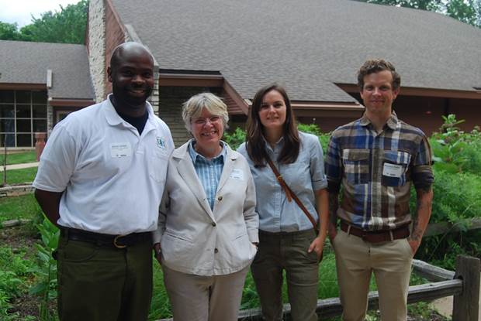Ms. Byrne noted, “This first year was a fantastic first step to helping to identify and support the needs of forest managers. Each new version will provide more specific help for professional forest managers and their partners.” Mr. Sudan added, “I think the training in monitoring bumble bee species will provide much needed base-line data for potential annual monitoring projects with Forest Service personnel and citizen scientists. Getting out in the field and learning the protocol made a big impression on the groups.”

The inaugural year of the trainings was initiated by Forest Service Region 9 through the work of **Jan Schultz, USDA Forest Service** Eastern Region Botany, Non-native Invasive Species and Special Forest Products Program Leader and **Daniel Jordan** also of USDA Forest Service.

Pictured above are Daniel Jordan (Potosi-F’town Wildlife Biologist), Jan Schultz (R9 Botany/NNIS Program Manager), Mary Byrne and Robinson Sudan both from the Pollinator Partnership ([www.pollinator.org](http://www.pollinator.org)).

The first training was held in Missouri at the **Mark Twain National Forest** at the MDC’s Powder Valley Nature Center on the southwest side of St. Louis last week. The second, held today in **Ironwood, Michigan at the Ottawa National Forest,** will influence several thousand acres of forest land. Participants came from as far away as Louisiana and left with a new set of skills to help protect and promote pollinators. They build on a long history of cooperation between the Forest Service and P2 which have collaborated through a memorandum of understanding for more than 12 years to provide mutually beneficial, science-based conservation programs and tools, including the extremely popular Bumble Bee identification guides for the United States which are found at <http://www.pollinator.org/books.htm>. In fact, **U.S. Forest Service Chief Botanist Dr. Larry Stritch** facilitated the very first Pollinator Day in 2007 through a proclamation signed by then-USDA Secretary Mike Johanns.

Pollinator Week has grown exponentially in scope each year with this year June 16-22 designated by **U.S. Secretary of Agriculture Tom Vilsack, U.S. Secretary of the Interior Sally Jewell,** and **45 governors** as a week to celebrate and protect the nation’s pollinating animals (Acomplete list is available at <http://pollinator.org/npw_events.htm>). Pollinators, like bees, butterflies, birds and other animals, bring us one in every three bites of food and protect our environment. They form the underpinnings of a healthy and sustainable future. With this new training, Pollinator Week marks a new dawn of wise land management across the country.

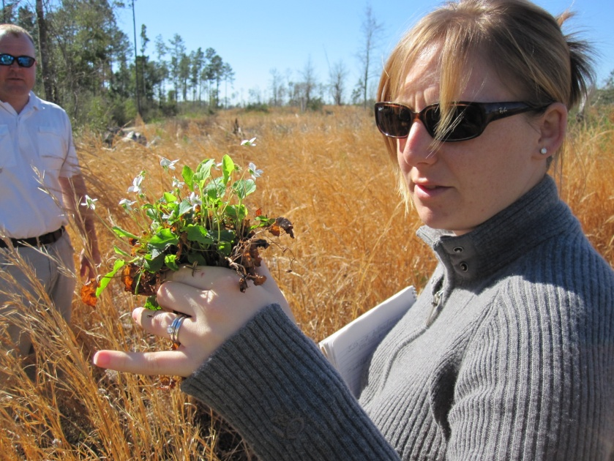“We are thrilled to see the enthusiastic reception this forest management training has received,” said **Laurie Davies Adams**, Executive Director of P2. “It is a very good day for pollinators!”

As feedback is received from these first two sessions, P2 will build on its experience within commercial forests studying the management practices of **Greif, Inc.’s Soterra** forests in Mississippi, studied under the supervision of P2’s **Dr. Vicki Wojcik** (pictured at right),including the elimination of chemical impacts on pollinators. Further, the training will include the very well-developed USDA Forest Service techniques advanced by the visionary leadership of **Chief** **Tom Tidwell**.

Efforts during Pollinator Week, and indeed year-round, are working to reverse and prevent pollinator declines caused by loss of habitat, disease, pesticides, parasites and other interconnected assaults on pollinator populations.

###

**ABOUT THE POLLINATOR PARTNERSHIP (P2)**

Established in 1997, the Pollinator Partnership is the largest 501(c) 3 non-profit organization dedicated exclusively to the health, protection, and conservation of all pollinating animals. Pollinator Partnership’s actions for pollinators include education, conservation, restoration, policy, and research. P2’s financial support comes through grants, gifts, memberships and donations from any interested party. Its policies are science-based, set by its board of directors, and never influenced by any donor. To make a donation or for information on events during Pollinator Week, visit [www.pollinator.org](http://www.pollinator.org).