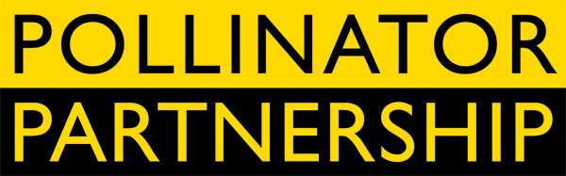

June 20, 2011

Tom Van Arsdall tva@pollinator.org t 703.509.4746

Sunny Boyd sun@pollinator.org t 415.362.1137
Pollinator Week Unites the Nation for the Birds and Bees

5th Annual National Pollinator Week, June 20-26th Brings Action for Vital Pollinators

Washington, DC - Sec. of Agriculture Tom Vilsack put the official stamp on Pollinator Week with a signed proclamation, and he was joined by more than 30 US State Governors in designating June 20-26 as Pollinator Week. Pollinator Week is being celebrated not only in the US, but also in Canada, Mexico, and around the globe.
Congressional Briefing - Members of Congress, their staff, and the public are invited to participate in a briefing by pollinator scientists and experts on Thursday, June 23 at 4:00 PM at the Longworth House Office Building Room 1302. As a special pollinator treat, pollinator supportive companies Häagen-Dazs and Burt’s Bees will provide ice cream and lip balm for attendees. Both Burt’s Bees and Häagen-Dazs are committed to the health of honey bees that are instrumental in their products and in the well being of plants, people, and animals. The briefing is being held in conjunction with the Congressional Pollinator Protection Caucus (CP2C), which was created in the House by co-chairs Alcee Hastings (D-FL) and Timothy V. Johnson (R-IL) to increase understanding of the importance of pollinators in land management, food, and the environment.
New Legislation to be Introduced - A widely supported effort to decrease the costs of roadside management by reduced mowing and increased native plantings, the Highways Bettering the Economy and Environment Act (Highways BEE Act), will be introduced on Thursday, June 23 as part of Pollinator Week. Rep. Hastings and Rep. Timothy V. Johnson will be lead sponsors of the bipartisan legislation. “Our bill’s approach is to help States reduce roadside maintenance costs while providing better habitat for pollinators—similar to farmers being good conservationists while they produce our food,” noted Rep. Johnson. “Neighboring farmers will benefit from improved ag pollination services.” Rep. Hastings added, “Many conservation approaches are viewed as adding costs – this measure is designed to help cash-strapped states reduce roadside maintenance costs, while providing habitat for pollinators and other benefits. Everyone wins; we save money, and the safety of our nation’s highways is enhanced.”
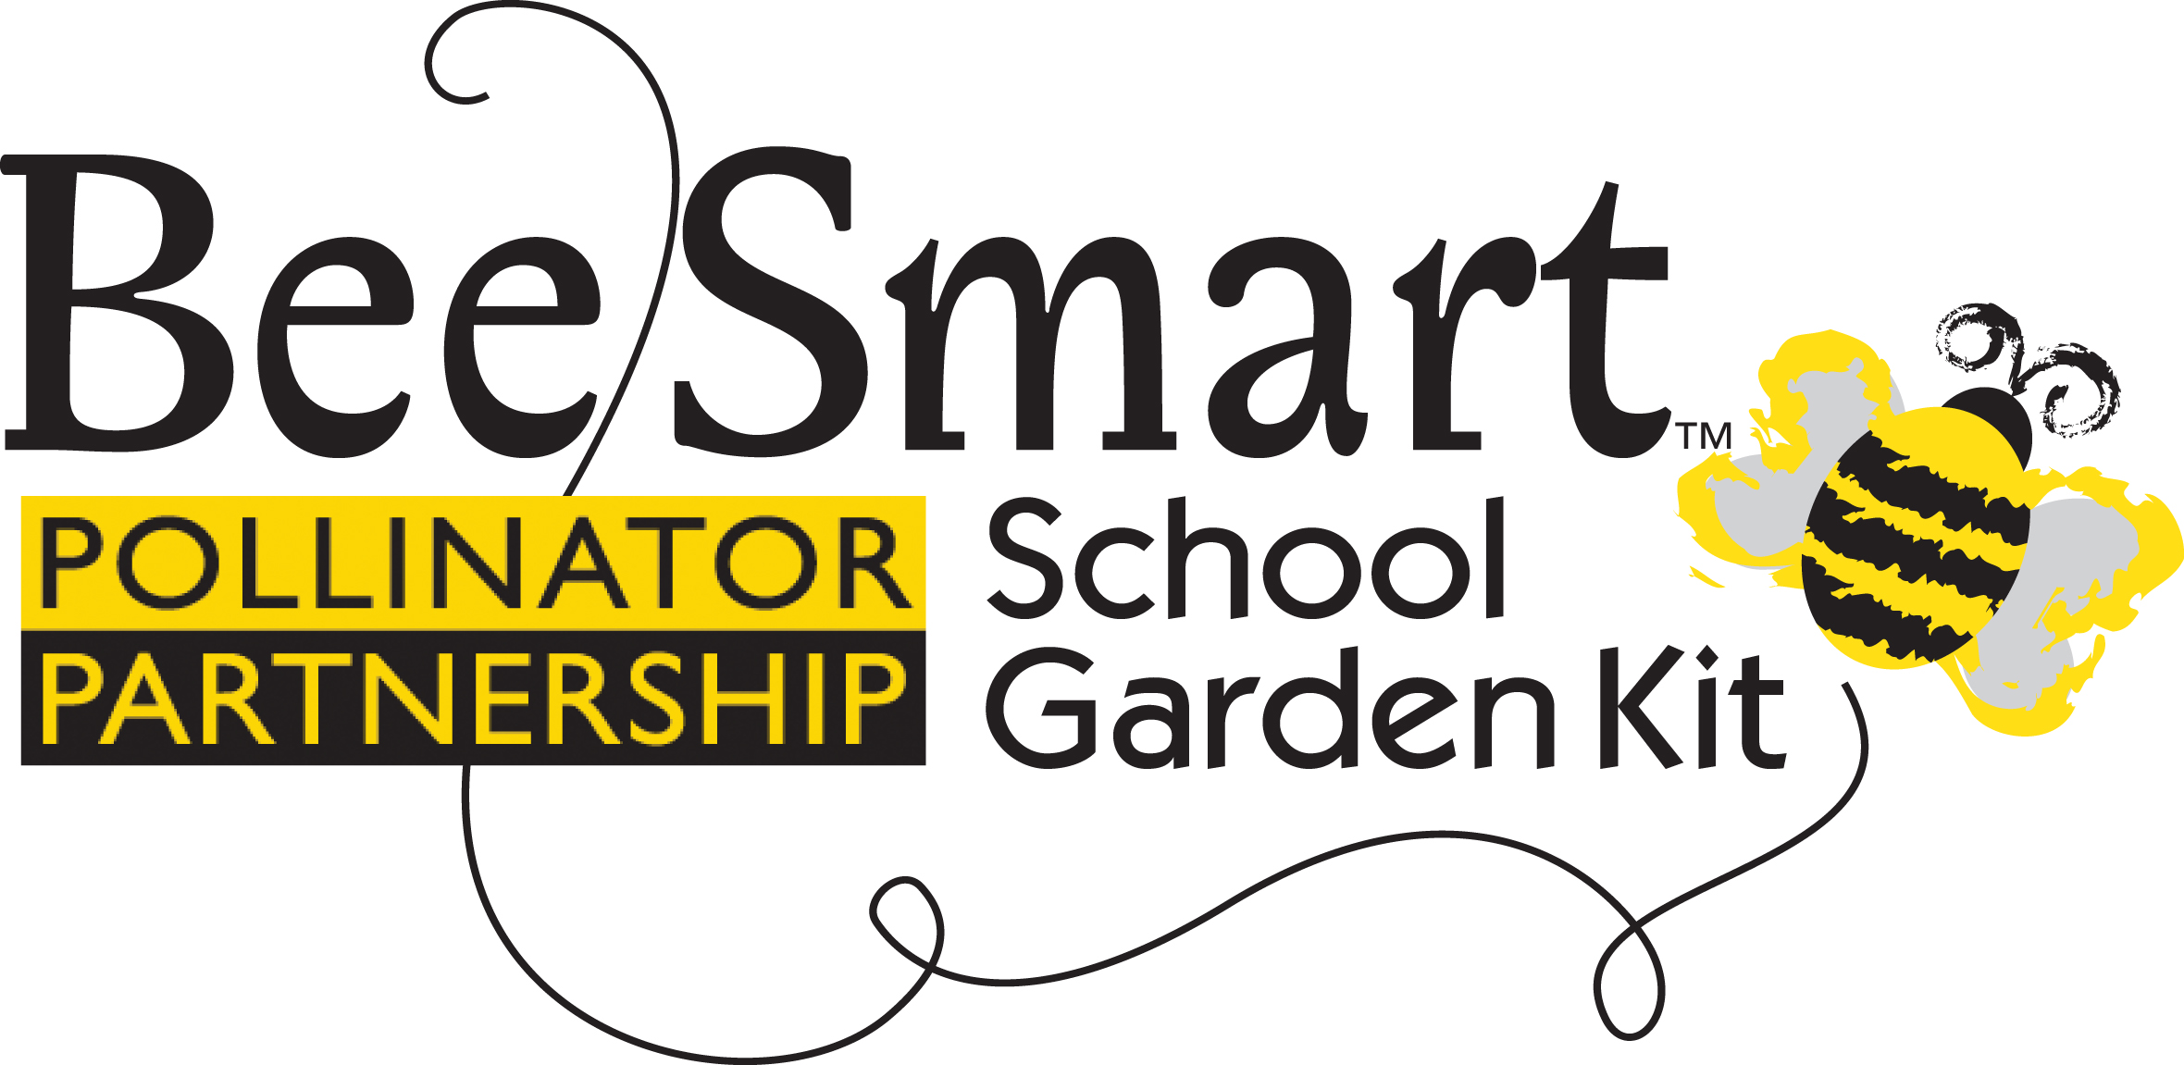
The Highways BEE Act seeks no new monies and the limited federal role is to assist the states. It has received widespread endorsement from the business and environmental communities as well as from House Members on a bipartisan basis, scientists and diverse organizations including National Audubon, National Farmer’s Union, The Isaac Walton League, The American Farmland Trust, Waste Management, The National Gardening Association, among others.

Also as part of National Pollinator Week, the Bee Smart ™School Garden Kit will be introduced. The kit is a new pollinator discovery tool for grades 3 through 5 to learn first-hand the connection between plants, pollinators, and the food we eat. The kit contains 10 lesson plans, seeds for sprouting, and learning games to help students expand their knowledge of science, language arts, and math – plus the lessons can be highly effective whether or not there are school resources to build an onsite garden. The Bee Smart™ School Garden Kit will be previewed during Pollinator Week and will be delivered in early September in time for the school year.

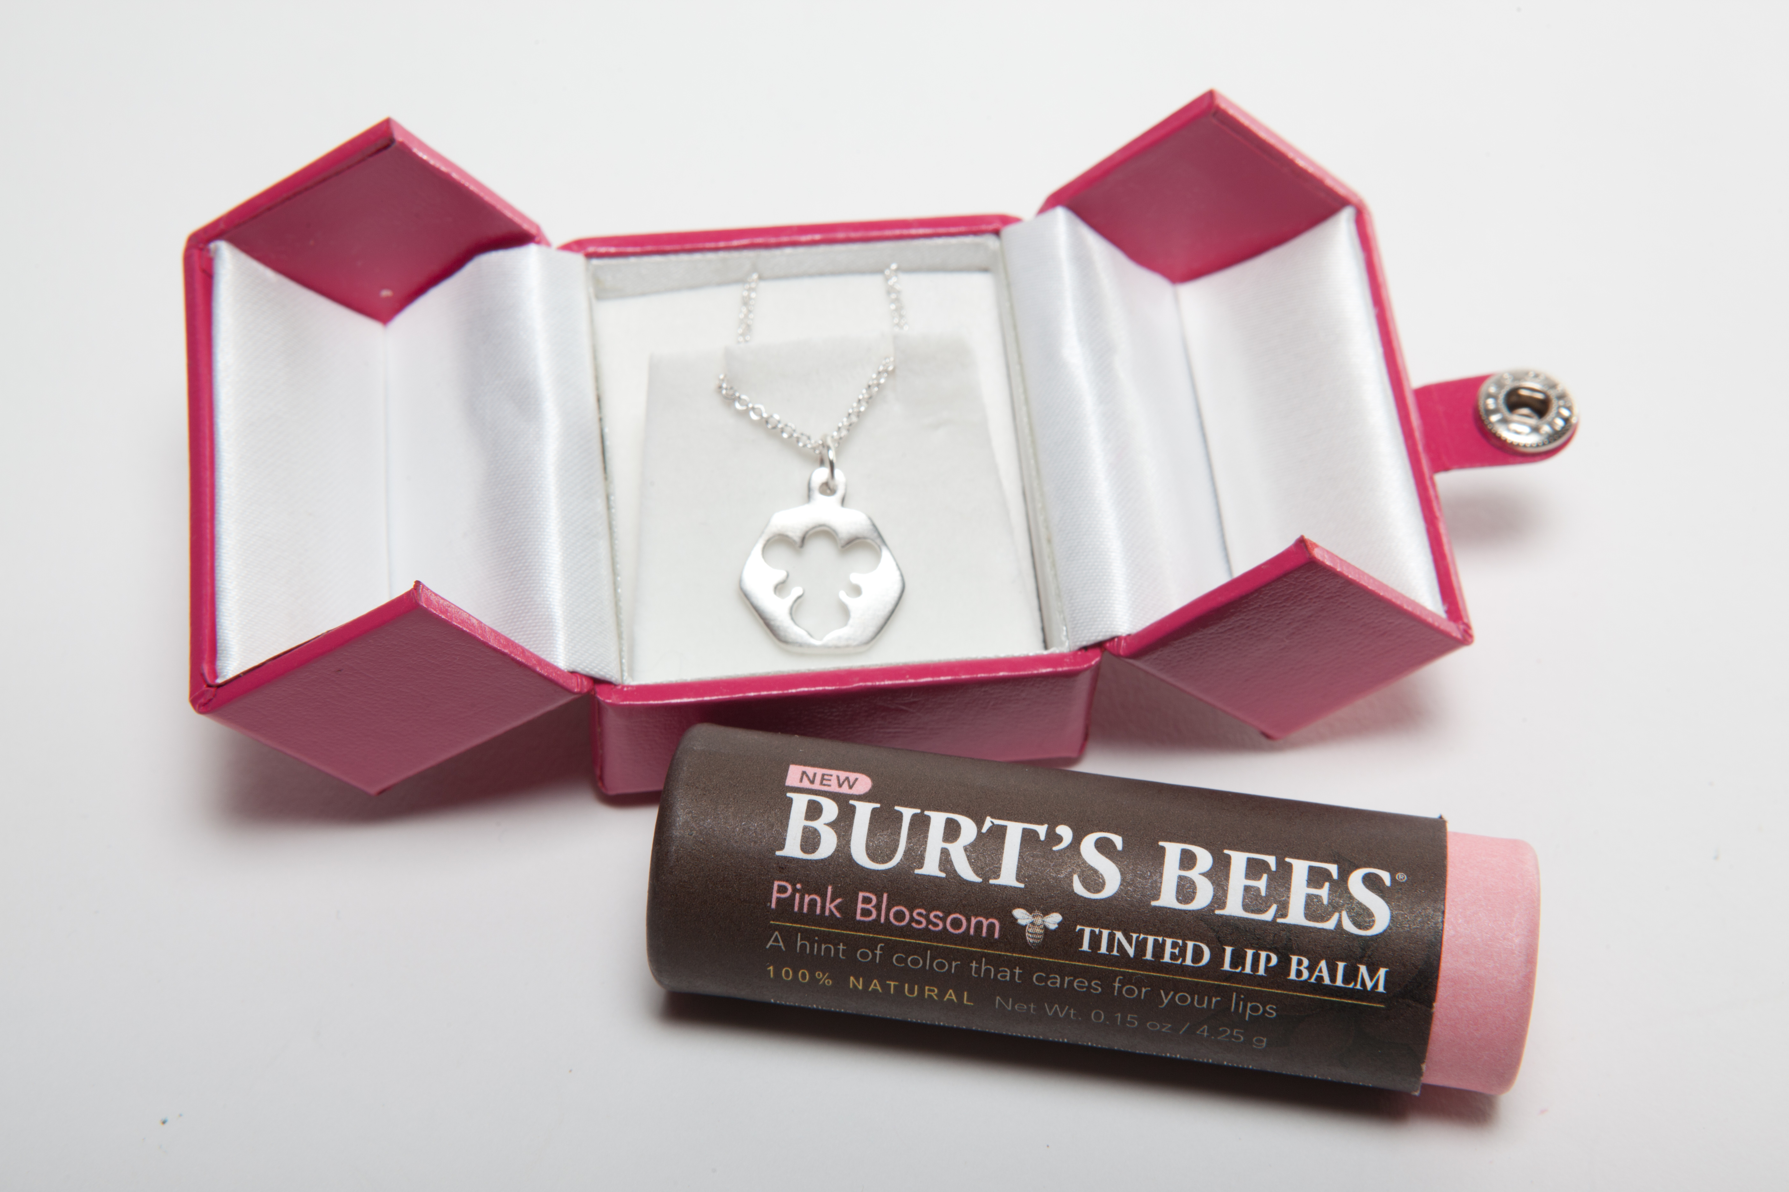
A Charm for Bees: As a special tribute to pollinators, Burt’s Bees has teamed up with notable jewelry designer, Helen Ficalora to honor the bees with a special charm. Until September 3rd, donations of $150 or more to Pollinator Partnership will receive a one-of-a-kind Helen Ficalora sterling silver Bee Charm Necklace (valued at $100) and a beautiful Burt’s Bees® Tinted Lip Balm in Pink Blossom(valued at $7). Proceeds will go toward sending a Bee Smart™ School Garden Kit to qualified, under-served schools.

Pollinator Week events across the nation are listed by state at www.pollinator.org. Here is a sampling from the East Coast:

New York City: On Wednesday, June 22, from 5 to 8 P.M. Helen Ficalora’s New York City SOHO shop (21 Cleveland Place) will be the site of a special Pollinator Week event co-hosted by Burt’s Bees and featuring raffles and giveaways from Burt’s Bees and Helen Ficalora Visit www.burtsbees.com/begoodtobees for full details on the charm.
Other Washington DC Events: On Friday, June 24 a Pollinator Festival will be held from 10 am to 2 pm on the National Mall outside of the U.S. Department of Agriculture next to the People’s Garden and the USDA Farmer’s Market. Booths from nearly 15 federal agencies and nonprofits will feature pollinator information and activities including those just for kids.

NEW FREE POSTER: “Join the Conversation about Native Bees” is the theme for 2011 Pollinator Week. Schools, corporations, garden clubs, nature centers, and government groups sponsor events which teach pollinator-friendly practices and raise public awareness about the importance of the nearly 4000 species of native bees found in the U. S. alone. Pollinator Week includes new and fun outreach elements such as the free poster (pictured below), free pollinator brochures specifically targeted to help Monarchs, engage schools, give gardeners tips for wise pesticide application, and more. Visit www.pollinator.org/shop.

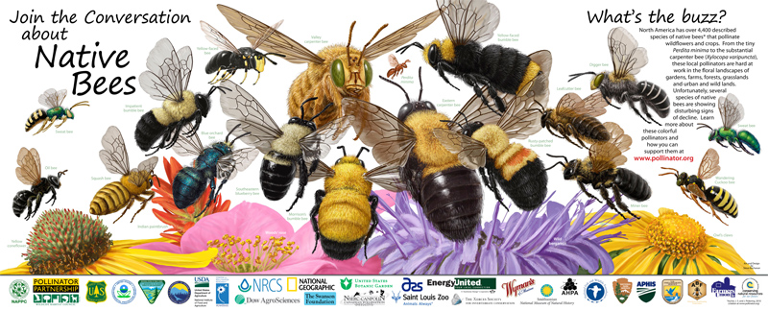
National Pollinator Week is a project of the North American Pollinator Protection Campaign (www.nappc.org), managed by the Pollinator Partnership. Laurie Davies Adams, E.D. of the Pollinator Partnership commented on the many Pollinator week activities, “From schools in the Great Plains to garden groups in the South; from our nation’s top cities to agricultural landscapes; from backyards to board rooms, people and pollinators are uniting. The support of business is a key to all these activities, and we are grateful for the invaluable support we have received from our partners, especially in reaching out to the nations’ school children. Students will experience a connection to their food and to their future through the Bee Smart program thanks to Burt’s Bees, Helen Ficalora and the Pollinator Partnership.” Established in 1997, the Pollinator Partnership (P2) is the largest 501(c)3 non-profit organization dedicated to the health, protection, and conservation of all pollinating animals. To donate or to learn more visit www.pollinator.org.

