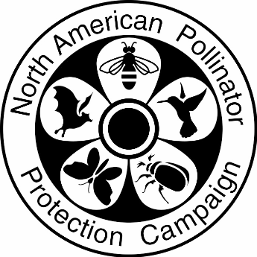

**NAPPC Electric Power Award**

We are very excited that you are nominating a project for the NAPPC Electric Power Pollinator Award! We would like to clarify a few details to support you most effective nomination.

Please be sure to provide plenty of detail in your nomination. The more detail and description provide, the more the information the selection committee will have to rank your project. Use as much space as you need to provide complete answers. Include photos when possible.

This NAPPC award is a notable award given only to highly deserving projects. If no deserving projects are nominated, NAPPC may choose to not provide any awards in this category.

NOTE: This award is for a SPECIFIC PROJECT. It is not for a company/agency as a whole. Please do not submit nomination forms for a collective set of efforts of an organization, as they will not be considered.

NAPPC may request the top-ranking nominations to present to the selection committee, at their request.

The following are the 4 primary considerations for the reviewers:

1. Commitment to the pollinator project, including long-term maintenance plans.
2. Vegetation management practices, including plant selection and site management.
3. Education & Engagement, including use of signage and public outreach.
4. Monitoring and measured benefit to pollinators.

**Fill out the online form at** [**https://www.pollinator.org/nappc/electric-power-award**](https://www.pollinator.org/nappc/electric-power-award)**.**

**If you have questions, please feel free to reach out to Savannah Autran.** [**savannah@pollinator.org**](mailto:savannah@pollinator.org) **415-362-1137**

**Contact Information (Nomination Submitter)**

Name:___ ____________________­_ Organization:___________________

Email:_________________________ Phone:________________________

**Energy Project Information (Nominee)**

Project Name:___________________ City:______________ State:__________

Name: _________________________ Organization:__________________

Email:__________________________ Phone:_______________________

**Project Collaborators** (add up to 3 collaborating organizations)

Collaborator Name: Contact Name: Email:

Role:

**Please address each of the questions below in as much detail as possible.**

1. Brief Project Description:
2. What is the area of the project (i.e. acres, hectares)?
3. How will the habitat be maintained and for how long (i.e. years)? Describe the maintenance plan.
4. What species were planted? Provide a species list and/or the proportion of native, non-invasive, and proportion of grasses and forbs. Please list how many species in each bloom period.
5. What vegetation management practices (conservation mowing, herbicide and insecticide use, etc.) are being incorporated into the project in a way to support and protect pollinators? Are the people that will be maintaining the site trained in pollinator-promoting land management techniques?
6. Describe how the project engages the public through outreach (include any Pollinator Week activities)?
7. Describe any signage incorporated at the project site (include pictures).
8. Are the benefits of the site to pollinators monitored, quantified, and/or documented? Is the data from the on-site monitoring reported to the public? Please, describe.