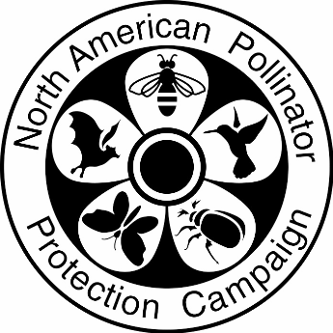

NAPPC Electric Power Award
Use as much space as needed to completely answer each question.

Contact Information (Nomination Submitter)

Name:_________________________ Organization:___________________

Email:_________________________ Phone:________________________

Energy Project Information (Nominee)

Project Name:___________________ City:______________ State:__________

Name: _________________________ Organization:__________________

Email:__________________________ Phone:_______________________

Please address each of the questions below in as much detail as possible.
Brief Project Description:

How has pollinator supporting vegetation been incorporated into project activities. What species are being used?

How is the project promoting vegetation management practices (conservation mowing, IVM use, etc.) that incorporate the needs of pollinators?

Explain the measured positive impacts of the Utility’s pollinator initiative for the ecosystem and people.

Describe how the project engages the public through education and outreach as well as signage.

Provide the amount of documented Rights-of-Way miles/acres impacted, or other ecologically-based metric, by the Utility’s pollinator initiative.

