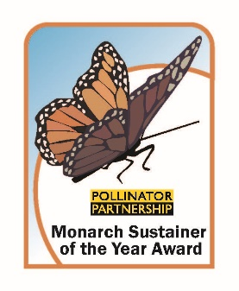
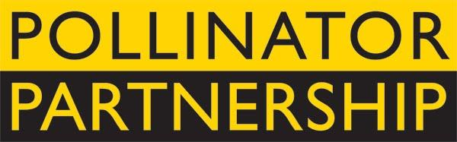
Monarch Sustainer of the Year Award, an initiative to recognize business in supporting the long-term viability of monarch butterflies.

Monarchs rely on a network of nectar plants and milkweeds that stretches across North America to sustain them on their annual journey from summer breeding grounds to overwintering habitats. Many factors have fragmented the migratory corridors monarchs rely on during this journey. Helping monarchs means filling these habitat gaps to sustain the monarch migration so that generation after generation can enjoy their wonder. It also means spreading the word on the need to conserve and protect this unique insect that takes on an epic journey.

The Monarch Sustainer of the Year Award recognizes a US business that has shown exceptional leadership and action in providing habitat and awareness for monarchs along their migratory corridors. Pollinator Partnership is a proud member of the Monarch Joint Venture (www.monarchjointventure.org) that strategically supports the monarch through the North American Monarch Conservation Plan.

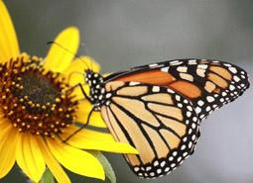
To submit an application for this award please complete the questions on the following page, providing a narrative and supporting documents (photographs, site plans, outreach plans, etc.) that highlight the unique and inspiring ways in which your business is supporting monarchs and meeting the award criteria. The application package should include a completed cover sheet, a narrative highlighting how your monarch conservation program meets the stated technical and organizational criteria, and any supplementary materials that you would like to share. Please send/upload all attachments as a PDF.

Key Dates
December 1, 2021 – Deadline for Applications
January 2022 – Announcement of Winner

Award Criteria
To qualify for the Monarch Sustainer of the Year Award a business must make an effort to increase and/or enhance nectar and host plants within the migratory pathways of monarchs. Activities can be focused on single localities or on multiple sites within the Pacific, Central, and Eastern migratory routes. Qualifying businesses include: For-profit corporations, municipalities, and for-profit schools. In all cases entities must prove they are going above and beyond their business mission and priorities.

Technical Criteria - Provide clean and safe habitat for monarchs.
- Milkweed is essential and a successful monarch conservation plan cannot be developed without the right species of milkweed in the right place. Monarch caterpillars need this to survive and thrive.
- Nectar plants are needed to support adult butterflies and need to be in bloom throughout the growing season.
- A habitat that is free of chemical inputs and noxious weeds is also essential. Any management plans need to include integrated approaches to managing pest issues.

Outreach Criteria - Take a leadership role in developing programs that go beyond habitat installations and tell us how this has changed the way you do business.
- Show a clear internal program or policy for monarch support that is integrated into your green or sustainable guidelines and/or programs.
- Provide opportunities for employees and/or local community members to engage in monarch conservation activities.
- Show a record of corporate outreach and engagement within your industry to encourage monarch conservation.
- Show a record of public outreach and engagement.
- Important metrics include: Employees/Volunteers engaged, community members impacted, social media reach etc.

Pollinator Partnership (P2)
Established in 1997, Pollinator Partnership is the largest 501(c) 3 non-profit organization dedicated exclusively to the health, protection, and conservation of all pollinating animals. All P2 projects are science-based and collaborative and support conservation, education, research, policy and monitoring. Further information is at www.pollinator.org.

Monarch Sustainer of the Year 2021 Application

Business Name:____________________________________________________________________________________

Address:__________________________________________________________________________________________

Program State/Region: _____________________________________________________________________________________

Primary Application Contact: _________________________________________________________________________

Media/Public Relations Contact: ______________________________________________________________________

- Provide a brief overview of your monarch conservation program.

- Tell us your “Monarch Story” – how has this project evolved and affected your company, community, and the monarch migration? (Use more pages as needed)

- List the species of milkweed that have been planted:

- How many milkweed plants/lbs. of seed have been planted?

- List the species of nectar plants that have been planted:

- How many nectar plants/lbs. of seed have been planted?

- What is the total project area?

- Please attach a technical and organization criteria narrative and any supporting photographs or documents to this cover sheet.

- Have you done anything that supports an element of the North American Monarch Plan (https://www.fs.fed.us/wildflowers/pollinators/Monarch_Butterfly/conservation/conservation_plan.shtml)?

- Have you participated in National Pollinator Week (www.pollinator.org/pollinator-week)?

Send applications by email to info@pollinator.org with subject indicating “Monarch Sustainer of the Year”.
PHOTO documentation encouraged and best sent via thumb drive to the address below. For more information please contact:
Pollinator Partnership – 475 Sansome Street 17th Floor, San Francisco CA 94111 - 415-362-1137 www.pollinator.org

