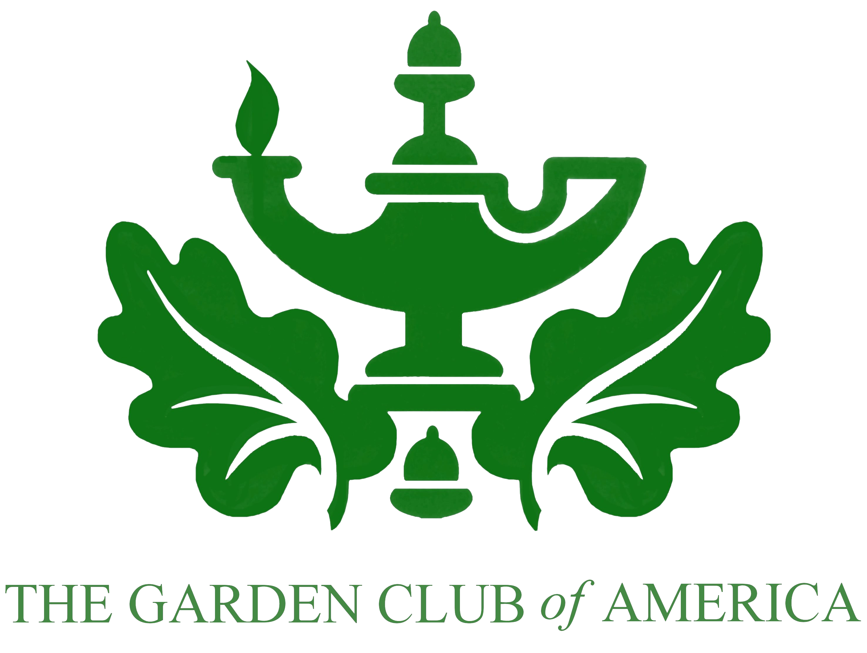

The Garden Club of America Board of Associates

Centennial Pollinator Fellowship

Letter of Recommendation Form

DATE:

We are requesting this letter of recommendation form as part of your student’s application for The Garden Club of America Board of Associates Centennial Pollinator Fellowship. You may attach a letter in addition to the form.

REFERENCE’S CONTACT INFORMATION

Your Full Name

Relationship with Applicant

Telephone Number

Permanent Email Address

University

University Mailing Address

May the selection committee contact you for further information? Yes No

The applicant is properly enrolled in graduate school. Yes No

APPLICANT INFORMATION

Full Name

Telephone Number

Degree Expected

Enrollment Date

Expected Graduation Date

Describe this student’s progress to date in their degree program:

How would you rate this student’s academic ability compared to other students in your program?
Below Average | Average | Above Average | Top 5% | Top 1%

Describe this student’s potential for a pollinator-related career:

Why do you recommend this student for The GCA Pollinator Fellowship?

Please evaluate the student’s ability as an independent researcher and/or leader. Give examples where possible:

SUBMISSION DETAILS
Please submit your recommendation letter as a PDF directly to Kelly Rourke via email at kr@pollinator.org by February 1, 2018.

Please contact us at 415.362.1137 or kr@pollinator.org if you have any questions.

DECLARATION

I confirm that the information given on this form is, to the best of my knowledge and belief, true and accurate. I understand that if I have given misleading information on this form, this will be sufficient grounds for terminating the student’s application.

I agree that the information provided on this form may be shared with the Garden Club of America and the Pollinator Partnership.

Signature______________________________ Date:___________________

