October 16—via E-mail

RE: Request Senator’s Support for Including at Least $5 Billion More for Conservation Funding in the Senate Farm Bill

Dear Senator:

On behalf of the Coevolution Institute (CoE), I would like to request your support for including at least $5 billion more in additional funding for conservation in the Senate version of the farm bill. We understand that markup by the Senate Agriculture Committee is scheduled to start on October 23, with floor action in early November.

CoE appreciates that new provisions benefiting both wild and managed pollinators and their habitat are likely to be included in Conservation and Research Titles of the Chairman’s mark. However, this good intent must be supported by sufficient additional conservation funding to help American farmers and rancher implement essential conservation practices that will help pollinators and other wildlife and provide other important conservation benefits.

Pollinators are essential partners in much of agriculture and in healthy ecosystems. Strengthening farm bill conservation, research and other programs in the farm bill and providing sufficient funding to better address pollinator habitat needs and best management practices represent critical steps in sustaining and enhancing pollinators and their habitat.

The mission of CoE is to catalyze stewardship of biodiversity. CoE places a high priority on efforts to protect and enhance animal pollinators (invertebrates, birds and mammals) and their habitats in both working and wild lands. CoE manages and facilitates the North American Pollinator Protection Campaign (NAPPC), a public-private collaboration dedicated to ensuring sustainable populations of pollinating invertebrates, birds and mammals throughout the United States, Canada and Mexico. More information is available at www.pollinator.org.

Sincerely,
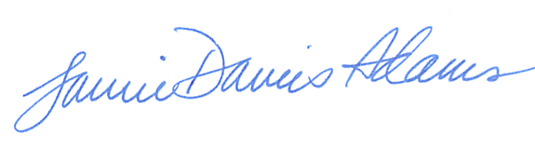
Executive Director

