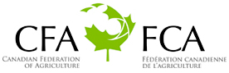
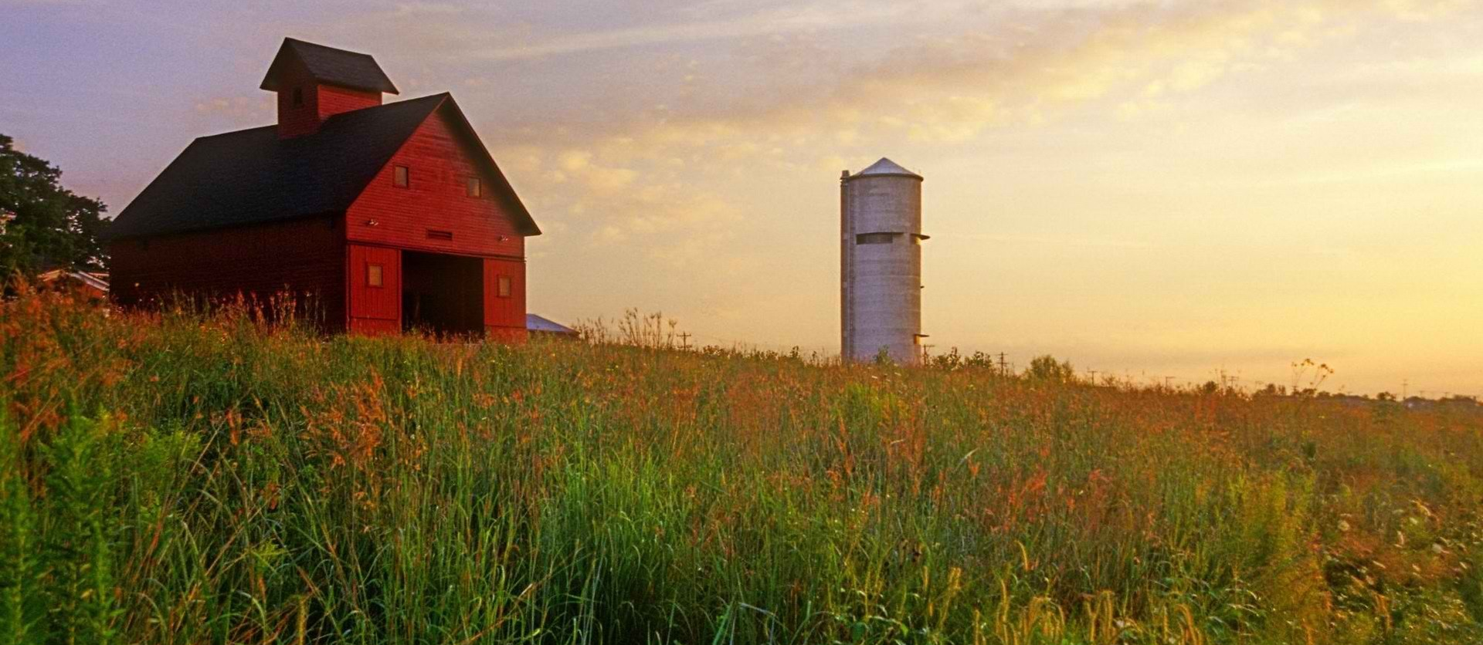
Canadian Farmer-Rancher
Pollinator Conservation Award

The Canadian Federation of Agriculture (CFA), Canadian Forage and Grassland Association (CFGA), and Pollinator Partnership (P2) are pleased to solicit nominees for the 2021 Canadian Farmer-Rancher Pollinator Conservation Award, recognizing an individual or family in the farm and ranch community in Canada who has contributed significantly to pollinator species protection and conservation.
With pollinators providing one of three bites of food that we eat and nearly $2B to the Canadian agricultural economy, care and concern for their survival is essential to our own survival. Pollinator Conservation Award winners support pollinators on their lands, engage in research and experimentation to increase our understanding of pollinator management techniques, work with community and government groups, and serve as advocates for these little, but hard-working, species that maintain our agricultural and natural landscapes.
The recipients of the 2021 award will be recognized during an award ceremony that opens the 21st Annual North American Pollinator Protection Campaign Conference on Tuesday, October 19, 2021.
Previous award winners include Ian Steppler of Steppler Farms Limited, Robin Hunt and Johan Bos of Big Rock Ranch; and The Farmlands Trust Society in British Columbia. Through recognition and appreciation of these individuals and organizations, we hope to encourage their conservation stewardship and catalyze future actions on behalf of pollinators. Visit http://www.pollinator.org/awards.htm to learn more.
To complete your nomination, please return the attached form to Savannah Autran at the Pollinator Partnership by deadline of Friday, July 16, 2021. Awardees will be notified no later than Friday, August 27, 2021.
Forms can be sent as an e-mail attachment to savannah@pollinator.org (please put “Canada Farmer-Rancher Pollinator Conservation Award” as the subject line) or mailed to 475 Sansome Street, 17th Floor, San Francisco, CA 94111.

Canadian Farmer-Rancher
Pollinator Conservation Award Nomination Form
Please return the attached form to Savannah Autran at the Pollinator Partnership by Friday, July 16, 2021. Forms can be sent as an e-mail attachment to savannah@pollinator.org (please put “Canada Farmer-Rancher Pollinator Conservation Award” as the subject line) or mailed to 475 Sansome Street, 17th Floor, San Francisco, CA 94111.
Supporter’s Information:
Name:
Organization, if applicable:
E-mail: Phone:

I wish to nominate the following individual or family in the farm and ranch community for the Canadian Farmer-Rancher Pollinator Conservation Award:
Nominee’s Name:
Farm/Ranch:
E-mail: Phone:

Nomination Narrative (Please provide a narrative or recommendation letter that speaks to the three points listed below. You may use this word document or attach separate sheets. Please keep submission at a maximum of 4 pages, not including images or representative materials):

1. Briefly describe nominees and their farm or ranch operation (location, size, crop, community).

2. Describe the contributions of the individual or family farmer/rancher to pollinator protection and conservation on working and wild lands, including but not limited to “on-the-ground” pollinator conservation, best management practices, landscape management techniques, etc.

3. Describe the contribution of individual or family farmer/rancher to the development of conservation partnerships, research partnership, demonstration projects that promote pollinator awareness and conservation, community and social/political actions that promote and protect pollinators, etc.

