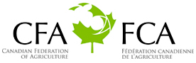
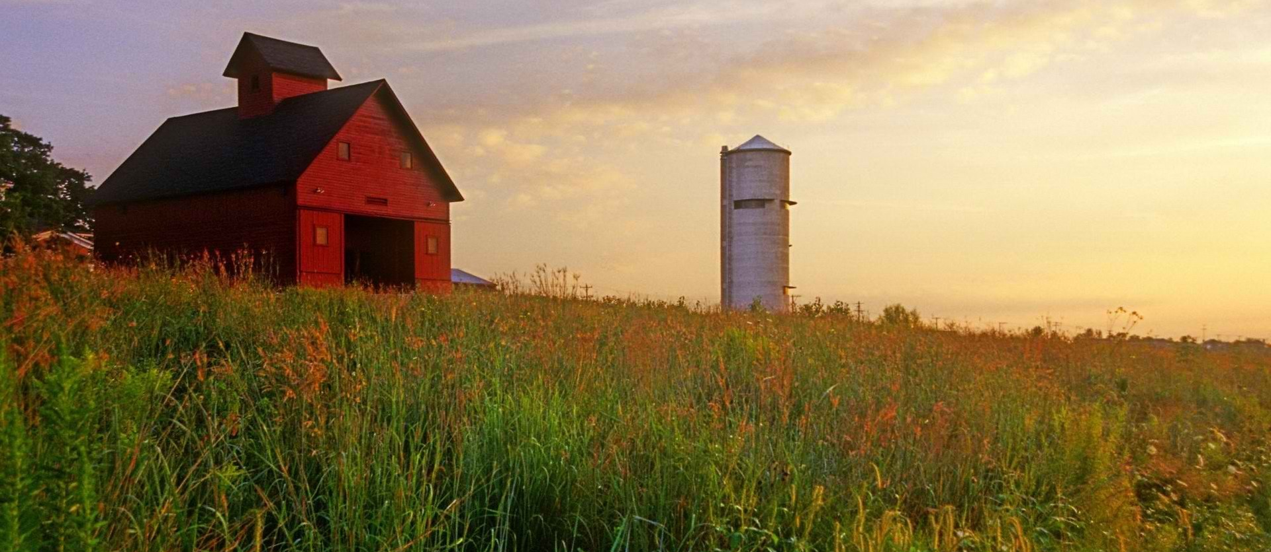
Canadian Farmer-Rancher
Pollinator Conservation Award

The Canadian Federation of Agriculture (CFA), Canadian Forage and Grassland Association (CFGA), and Pollinator Partnership (P2) are pleased to solicit nominees for the 2020 Canadian Farmer-Rancher Pollinator Conservation Award, recognizing an individual or family in the farm and ranch community in Canada who has contributed significantly to pollinator species protection and conservation.
With pollinators providing one of three bites of food that we eat and nearly $2B to the Canadian agricultural economy, care and concern for their survival is essential to our own survival. Pollinator Conservation Award winners support pollinators on their lands, engage in research and experimentation to increase our understanding of pollinator management techniques, work with community and government groups, and serve as advocates for these little, but hard-working, species that maintain our agricultural and natural landscapes.
The recipients of the 2020 award will be recognized during an evening reception that opens the 18th Annual North American Pollinator Protection Campaign Conference, Wednesday October 21, 2020 from 6:00 pm to 8:00 pm in Washington, DC, or in their hometown if they are unable to attend.
Previous award winners include Antony John of Soiled Reputation, Marc and Chantal Bercier of Ferme Agriber Inc; and the Coen Family of Grass Roots Family Farm from Ferintosh, Alberta. Through recognition and appreciation of these individuals and organizations, we hope to encourage their conservation stewardship and catalyze future actions on behalf of pollinators. Visit http://www.pollinator.org/awards.htm to learn more.
To complete your nomination, please return the attached form to Kelly Rourke at the Pollinator Partnership by deadline of Friday, July 10, 2020. Awardees will be notified no later than Friday, August 28, 2020 to allow for travel arrangements.
Forms can be sent as an e-mail attachment to kr@pollinator.org (please put “Farmer-Rancher Pollinator Conservation Award” as the subject line) or mailed to 475 Sansome Street, 17th Floor, San Francisco, CA 94111.

Canadian Farmer-Rancher
Pollinator Conservation Award Nomination Form
Please return the attached form to Kelly Rourke at the Pollinator Partnership by Friday, July 10, 2020. Forms can be sent as an e-mail attachment to kr@pollinator.org (please put “Farmer-Rancher Pollinator Conservation Award” as the subject line) or mailed to 475 Sansome Street, 17th Floor, San Francisco, CA 94111.
Supporter’s Information:
Name:
Organization, if applicable:
E-mail: Phone:

I wish to nominate the following individual or family in the farm and ranch community for the Canadian Farmer-Rancher Pollinator Conservation Award:
Nominee’s Name:
Farm/Ranch:
E-mail: Phone:

Nomination Narrative (Please provide a narrative or recommendation letter that speaks to the three points listed below. You may use this word document or attach separate sheets. Please keep submission at a maximum of 4 pages, not including images or representative materials):

1. Briefly describe nominees and their farm or ranch operation (location, size, crop, community).

2. Describe the contributions of the individual or family farmer/rancher to pollinator protection and conservation on working and wild lands, including but not limited to “on-the-ground” pollinator conservation, best management practices, landscape management techniques, etc.

3. Describe the contribution of individual or family farmer/rancher to the development of conservation partnerships, research partnership, demonstration projects that promote pollinator awareness and conservation, community and social/political actions that promote and protect pollinators, etc.

